**Need Client Environment Details**

This request mostly comes from EAC team. When we receive it as per the process we need to raise Jira for Skynet ops team. Since it’s a simple task Skynet ops told us to complete these requests whenever comes in the future.

**Example of actual request as given below:**

HD# 01369226 Need Environment information on the following Clients:

Need the Environment details (including NAT GATEWAY, TNS details, Batch Server SFTP Endpoint and AWS Account information) for the following clients.

**Environment Details:**

Client URLs for admin, private Api, Public Api, Membernet on all Environment like Dev, QA, UAT, Prod. This information can get from Skynet UI. When you search for a client,

Go to configurations -> Second page on the right pane. You can find the URLs as below.

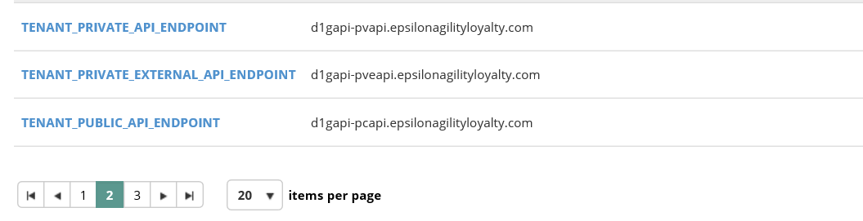

**NAT Gateway:**

Need to provide NAT gateway for each environment. We can get this from AWS console. Login to the specific client. Go to VPC -> Select NAT gateways. Provide the two NAT gateway IDs and Elastic IPs.

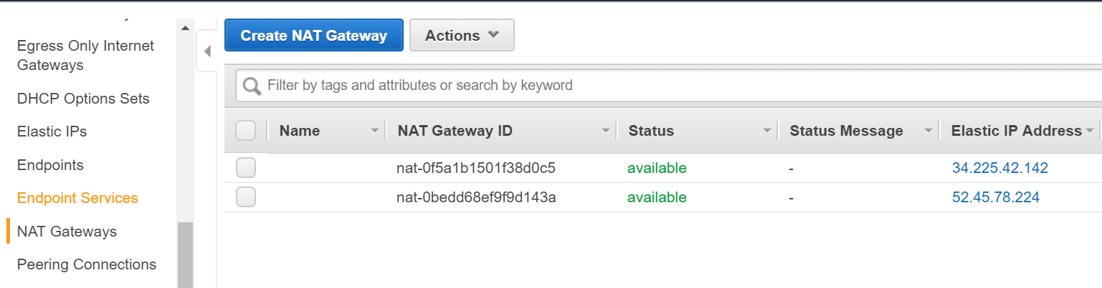

**TNS Details:**

Login to Skynet UI. Search for the client. Go to configurations -> Second page on the right pane. You can find the Tenant_DB_TNS. Provide the same to the client team.

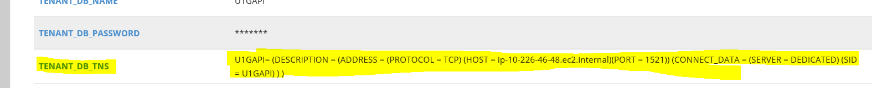

**Batch Server IP:**

Login to Skynet UI. Go to instances -> on the right pane. You can find the Batch IP as below.



**AWS Account Info:**

As per Skynet update, we should not share Aws account information to anyone. Up On getting proper justification from client team, we can verify with Skynet ops and provide the info.

-------------------------------------------------------------------------------------------------------------------------------